CSE 344 – Systems Programming
HOMEWORK #6 REPORT
Magic Academy

Name Surname | FATİH EMRE OĞAN
Student ID | 230104004090
Course | CSE 344 – Systems Programming
Homework | Homework #6 – Magic Academy

Table of Contents
1. Introduction 4
2. System Design 4
2.1 Single-Threaded Multi-Client Handling 4
2.2 Idle Timeout Recalculated Before Every select() 5
2.3 Rejecting New Connections at Full Capacity 5
2.4 Programs and Command-Line Parameters 5
3. Data Structures 6
3.1 Per-Client State (client_t) 6
3.2 Spellbook Management 6
3.3 Ingredient List 6
4. Partial Read / Write Handling 7
5. Signal Handling and Shutdown 7
5.1 Server Ctrl+C Sequence 7
5.2 Wizard and Professor Ctrl+C Sequence 7
5.3 Idle Timeout Disconnect 8
5.4 Server Full Rejection 8
6. Build and Usage 8
7. Test Scenarios 8
7.1 Scenario 1 8
Server Terminal 9
Wizard hermione Terminal 9
Professor dumbledore Terminal 10
Duplicate Username (hermione) Terminal 10
Pre-Enroll Command Terminal 11
7.2 Scenario 2 12
Server Terminal 12
Wizard harry Terminal 13
Professor mcgonagall Terminal 13
7.3 Scenario 3 15
Server Terminal 15
Wizard harry Terminal 16
Wizard ron Terminal 16
Professor dumbledore Terminal 17
Wizard voldemort Terminal (Rejected) 17
Professor snape Terminal (Rejected) 18
Wizard neville Terminal 18
7.4 Scenario 4 20
Server Terminal 20
Wizard hermione Terminal 21
Wizard harry Terminal (Idle Timeout) 21
Wizard ron Terminal 22
Professor dumbledore Terminal 22
Professor mcgonagall Terminal 23
8. Challenges 24
8.1 Recomputing the select() Timeout Without sleep() or Threads 24
8.2 Handling Partial TCP Messages and Clean Disconnection 24

1. Introduction
This report describes the design and implementation of the Magic Academy system for Homework #6. The system consists of three separate programs written in C: a single-threaded TCP server (hogwarts), a wizard client (wizard), and a professor client (professor). The server handles multiple simultaneous TCP clients using a single select() loop, with no thread-per-client and no use of sleep().
The server loads a list of magical ingredients at startup, manages per-client state including a personal spellbook for each wizard, enforces a maximum number of simultaneous clients, automatically disconnects idle clients after a configurable timeout, and shuts down cleanly on SIGINT. All client-server communication uses line-based TCP messages, and partial reads and writes are handled correctly.
The report explains the design decisions behind these mechanisms, documents the data structures used, and presents uncut terminal screenshots for all four mandatory test scenarios together with an explanation of each.

2. System Design

2.1 Single-Threaded Multi-Client Handling
The server never creates a thread or process per client. Instead, all file descriptors – the listening socket plus every connected client socket – are placed into a single fd_set and monitored by one select() call inside the main loop. This satisfies the requirement that all TCP I/O be handled inside one select() loop in a single thread.
Each iteration of the main loop performs four ordered steps:
- Idle timeout sweep: every connected client is checked, and any client idle longer than the timeout is disconnected before select() is called again.
- Build the fd_set: the listening socket and all client sockets are added, and the smallest remaining time until the next possible timeout is computed.
- Accept new connections: if the listening socket is readable, a new connection is accepted (and immediately rejected if the server is at capacity).
- Service existing clients: every client socket that is readable is read and its complete command lines are processed.
Because a single descriptor set drives the whole loop, the server scales to at least the maximum number of clients given by the -n option without any per-client thread.

2.2 Idle Timeout Recalculated Before Every select()
Idle timeout is implemented without sleep() and without threads. Each client record stores a last_active timestamp obtained with time(), updated whenever a command is received from that client.
Before every select() call the server recomputes the timeout as follows:
- It iterates over all connected clients and computes the elapsed time since each client's last activity.
- Any client whose elapsed time has reached the configured timeout is sent TIMEOUT DISCONNECT, the event is logged, and the client is removed.
- For the remaining clients, the earliest future expiry time is found, and the difference between that time and the current time is passed as the timeout argument (struct timeval) to select().
This guarantees that select() never blocks past the moment the next client would time out, so idle clients are disconnected promptly without busy-waiting or sleeping.

2.3 Rejecting New Connections at Full Capacity
The server tracks the current number of connected clients. When a new connection arrives while the server is already at the maximum (-n), the connection is still accepted with accept() so the client receives a meaningful response, then the server immediately sends ERR HOGWARTS_FULL, logs a REJECTED line with the file descriptor and IP address, and closes the descriptor without adding it to the client list.
Because the rejected descriptor is closed and never stored, a slot is recovered as soon as any existing client disconnects (via APPARATE, timeout, or hangup), allowing a subsequent client to connect successfully. This slot recovery behaviour is demonstrated in Test Scenario 3.

2.4 Programs and Command-Line Parameters
Three programs are produced. The server is started with five parameters and the clients with three positional arguments:
./hogwarts -p <tcp_port> -s <ingredients.txt> -l <logfile> -n <max_clients> -t <timeout>
./wizard <server_ip> <tcp_port> <username>
./professor <server_ip> <tcp_port> <username>
Invalid or missing parameters cause a usage message on stderr and a non-zero exit code. The port must be at least 1024, max_clients at least 1, and timeout at least 1.

3. Data Structures

3.1 Per-Client State (client_t)
The server keeps one client_t record for every connected client. The structure follows the minimum required structure from the assignment and adds a few fields needed for correct line buffering and spellbook management:
typedef struct {
int fd; /* client socket */
char username[32]; /* registered name */
char type[16]; /* WIZARD or PROFESSOR */
char line_buf[512+2]; /* partial read buffer */
int line_len; /* bytes currently buffered */
int enrolled; /* 1 after a valid ENROLL */
time_t last_active; /* timestamp of last command */
spellbook_entry_t spellbook[256];/* WIZARD only */
int spellbook_count; /* entries in use */
} client_t;
Client records are allocated dynamically with calloc() and stored in a pointer table. When a client disconnects for any reason (APPARATE, timeout, or hangup), its socket is closed, its memory is freed, and its slot in the table is cleared, so no file descriptor or memory leaks after a disconnect.

3.2 Spellbook Management
Each wizard has its own spellbook stored inside its client_t record as an array of spellbook_entry_t (an ingredient name and a quantity). A BREW command increases the quantity in both the global stock and the wizard's spellbook, creating a new spellbook entry if the ingredient is not present yet. A CONSUME command requires that both the global stock and the wizard's spellbook hold at least the requested quantity; otherwise ERR INSUFFICIENT_INGREDIENTS is returned. The spellbook is not persisted: it lives only inside the client record and is lost when the client disconnects.

3.3 Ingredient List
The global ingredient list is a fixed-size array of ingredient_t (name and quantity). It is loaded once at startup from the file given by -s. Each line must contain an ingredient name (uppercase letters, digits, or underscore, up to 16 characters) and a positive integer quantity; lines with an invalid format are skipped silently. Global quantities are updated by BREW and CONSUME and are always reported as non-negative integers.

4. Partial Read / Write Handling
TCP does not preserve message boundaries, so a single read() may return part of a line, several lines, or a line split across multiple reads. The server therefore keeps a per-client line buffer (line_buf) and a length counter (line_len).
On each readable event the server reads available bytes into the buffer after the existing data, then scans for newline characters. Every complete line (terminated by a newline) is processed as one command. Any bytes after the last newline are an incomplete line; they are moved to the front of the buffer and kept until the rest of the line arrives in a later read. A line longer than the maximum length is answered with ERR TOOLONG.
Partial writes are handled by a helper that loops on write() until all bytes of a response have been sent, restarting on EINTR. This guarantees that responses are delivered completely even if the kernel accepts only part of the buffer in one call. The clients use the same line-buffering technique when reading server responses, so split or merged server messages are also handled correctly.

5. Signal Handling and Shutdown

5.1 Server Ctrl+C Sequence
- The user presses Ctrl+C; the SIGINT handler runs and performs only an async-signal-safe operation – it sets a volatile sig_atomic_t flag.
- The main select() loop detects the flag at the next safe point and leaves the loop, entering shutdown mode.
- SERVER SHUTDOWN is sent to every connected TCP client.
- All client sockets and the listening socket are closed, and every client record is freed.
- SHUTDOWN signal=SIGINT and CLEANUP_DONE clients=0 are written to the log.
- The process exits cleanly with no zombie processes and no leaked file descriptors.

5.2 Wizard and Professor Ctrl+C Sequence
- The user presses Ctrl+C in a client terminal; the client's SIGINT handler sets a volatile sig_atomic_t flag.
- The main loop detects the flag and sends APPARATE to the server, then waits for the reply.
- The server responds with OK APPARATE and logs CLIENT_DISCONNECTED reason=APPARATE.
- The client prints DISCONNECTED reason=APPARATE, closes the TCP connection, and exits cleanly.

5.3 Idle Timeout Disconnect
When the server detects an idle client it sends TIMEOUT DISCONNECT, logs TIMEOUT username=X fd=N elapsed=Ns and CLIENT_DISCONNECTED reason=timeout, removes the client from the fd_set, and frees its state. The client prints a timeout message and exits cleanly.

5.4 Server Full Rejection
When a new client connects while the server is at capacity, the server accepts the connection, immediately sends ERR HOGWARTS_FULL, logs REJECTED fd=N ip=X reason=HOGWARTS_FULL, and closes the descriptor without adding it to the client list.

6. Build and Usage
All three programs are built with a single Makefile using the required compiler flags. The build produces zero warnings with -Wall -Wextra.
make # builds hogwarts, wizard, professor
make clean # removes all binaries and object files
Compiler invocation used by the Makefile:
gcc -Wall -Wextra -std=c11 -D_POSIX_C_SOURCE=200809L
A note on timeout values: in Test Scenarios 1, 2 and 3 the idle timeout was set to a longer value (90 seconds) so that the multi-terminal steps could be performed comfortably by hand. The timeout is a configurable command-line parameter and the underlying mechanism is identical regardless of its value. Test Scenario 4, which specifically demonstrates the idle timeout, uses the short value (10 seconds) as intended.

7. Test Scenarios
Each scenario was run with multiple terminals open simultaneously. Every terminal was screenshotted separately, and every screenshot is uncut, showing the full terminal from the command prompt through program exit. A fresh server was started for each scenario.

7.1 Scenario 1
Command:
./hogwarts -p 5000 -s ingredients.txt -l server.log -n 4 -t 90
Steps performed: wizard hermione and professor dumbledore connect; a second wizard with the same username hermione is rejected with ERR ENROLL name_taken; a third client connects and sends a command before ENROLL and receives ERR NOT_ENROLLED; hermione sends FLY BROOMSTICK (ERR UNKNOWN); dumbledore sends BREW and CONSUME (ERR UNAUTHORIZED); hermione sends INSPECT and SCROLL (ERR UNAUTHORIZED); hermione and dumbledore exit with Ctrl+C.

Server Terminal
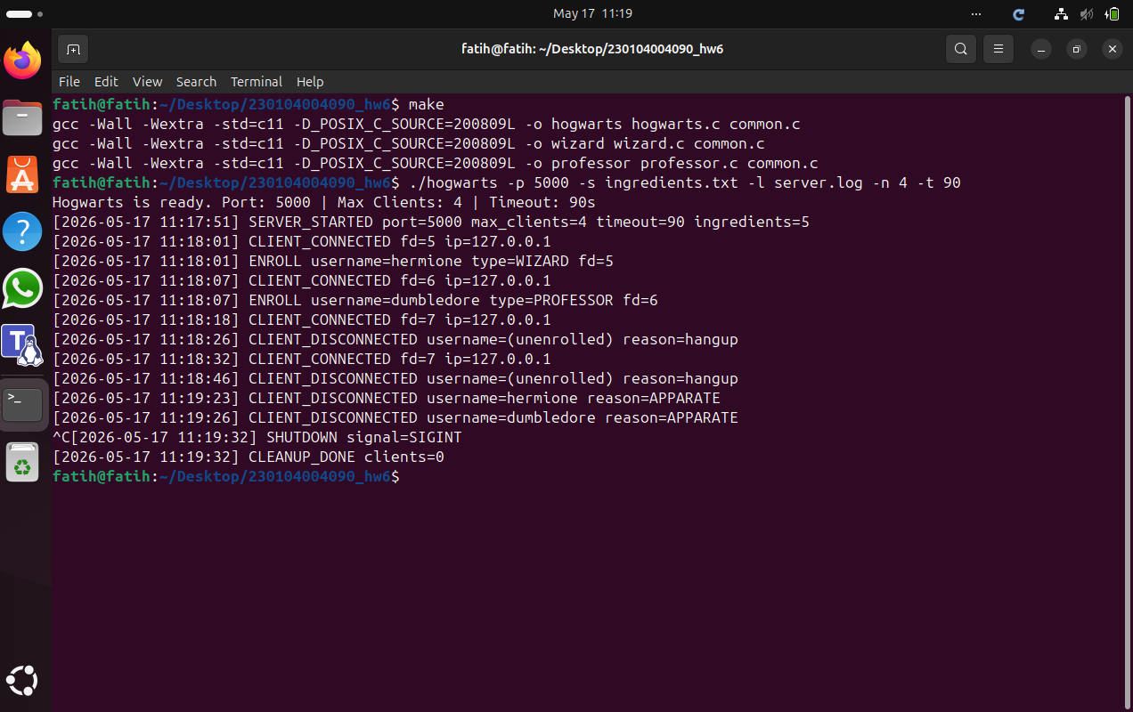

Wizard hermione Terminal
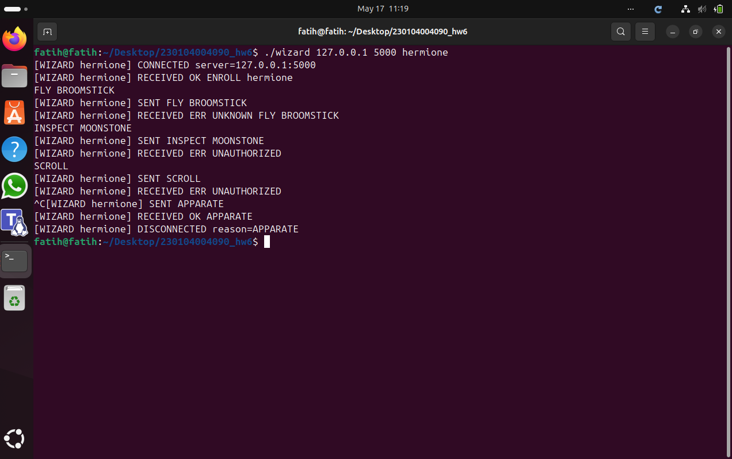

Professor dumbledore Terminal
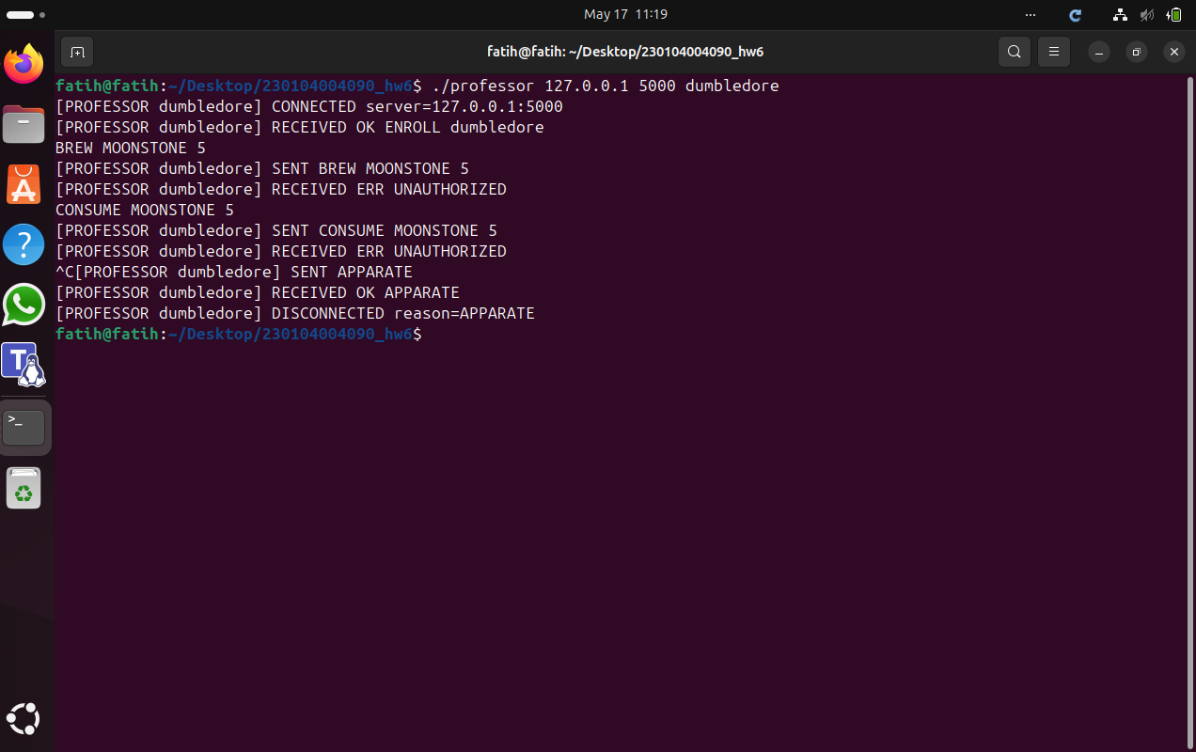

Duplicate Username (hermione) Terminal
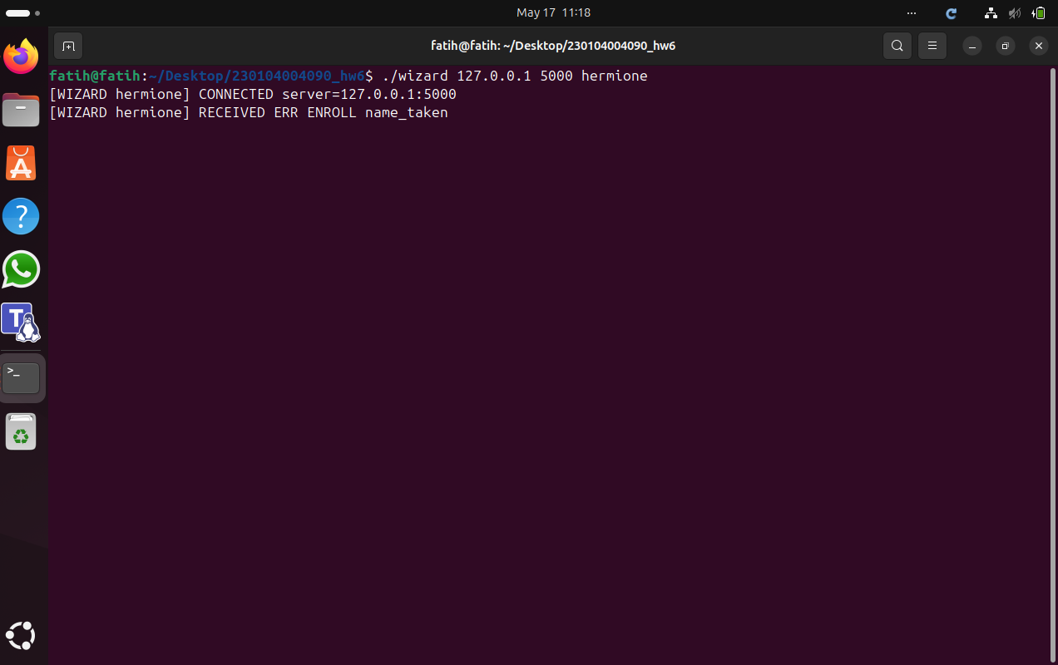

Pre-Enroll Command Terminal

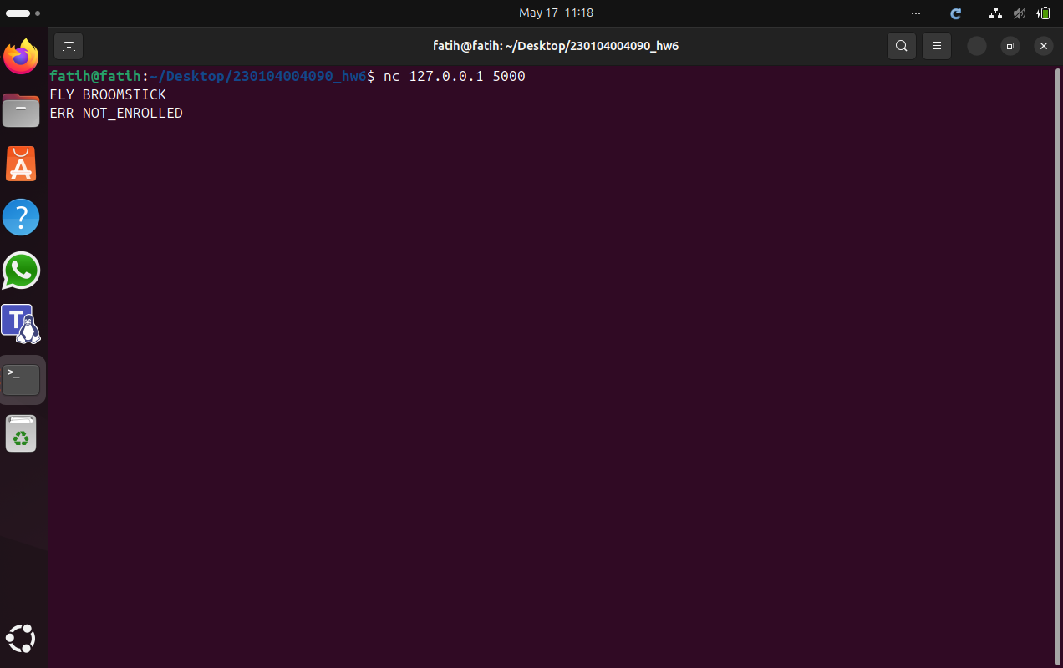
Explanation: The screenshots show that duplicate usernames are rejected, commands sent before ENROLL are rejected, unknown commands and unauthorized commands return the correct error messages, and both clients exit cleanly with APPARATE. The server log records every event in order. Note: Timeout was set to 90 s (instead of 30 s) only for manual convenience; the -t value is configurable and does not change the mechanism.
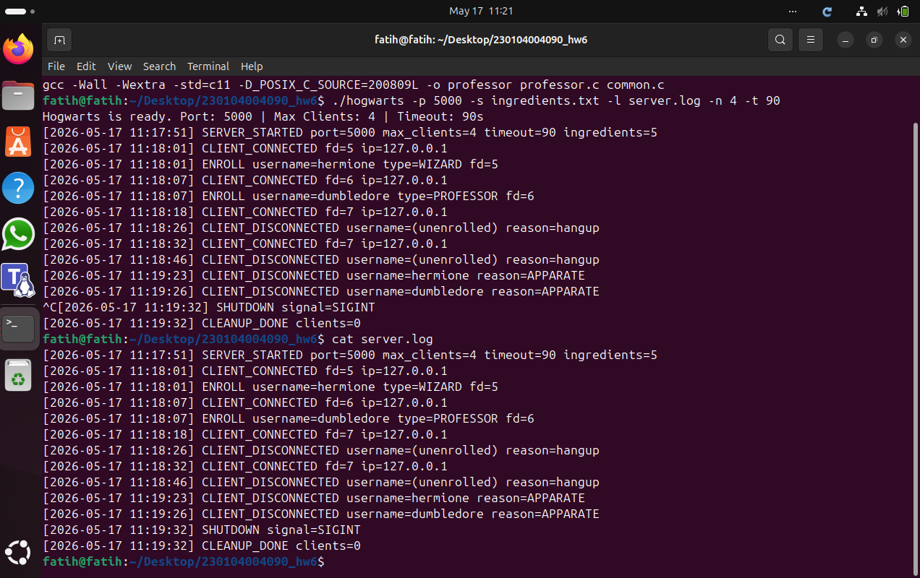

7.2 Scenario 2
Command:
./hogwarts -p 5000 -s ingredients.txt -l server.log -n 4 -t 90
Steps performed: wizard harry and professor mcgonagall connect. harry runs BREW MOONSTONE 10, SPELLBOOK, BREW UNICORN_HAIR 15, SPELLBOOK, CONSUME MOONSTONE 5, CONSUME UNICORN_HAIR 20 (insufficient), BREW BUTTERBEER 5 (unknown ingredient). mcgonagall runs INSPECT DRAGON_SCALE, SCROLL, ROSTER, INSPECT BUTTERBEER (unknown ingredient). Both exit with Ctrl+C.

Server Terminal
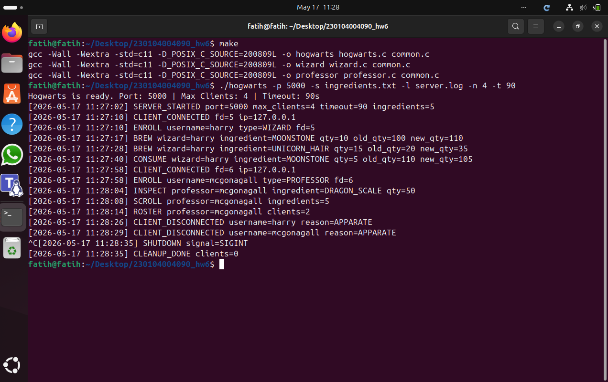

Wizard harry Terminal
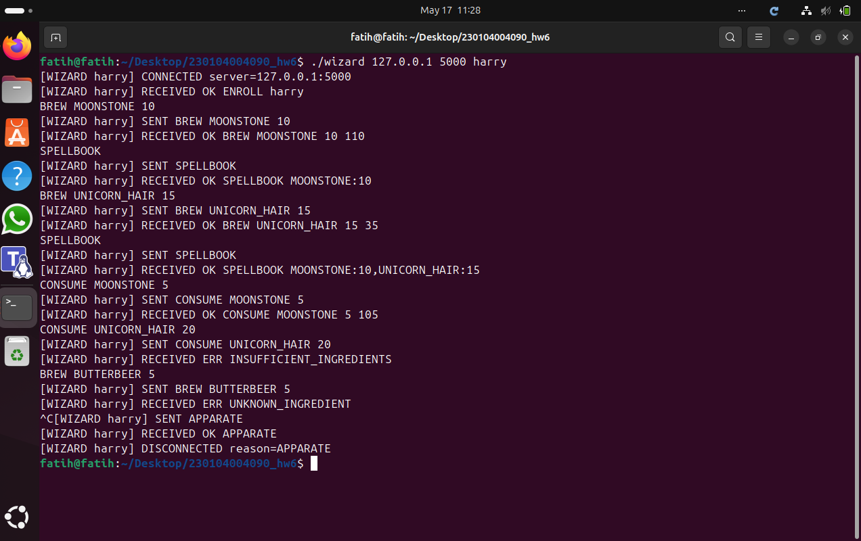

Professor mcgonagall Terminal
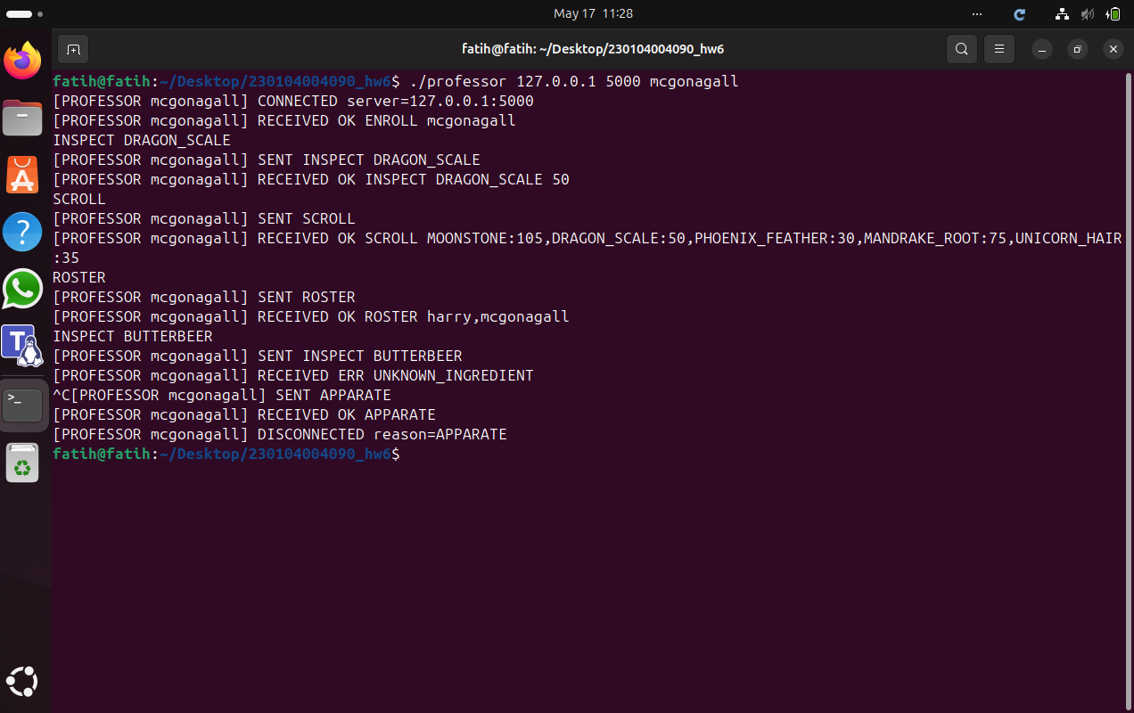

Explanation: The screenshots show that BREW and CONSUME correctly update both the global stock and the wizard's spellbook, that an over-consumption is rejected with ERR INSUFFICIENT_INGREDIENTS, that an unknown ingredient is rejected with ERR UNKNOWN_INGREDIENT, and that the professor queries (INSPECT, SCROLL, ROSTER) return consistent values matching the server log.
Note: Timeout was set to 90 s only for manual convenience; this does not affect the protocol behaviour shown here.
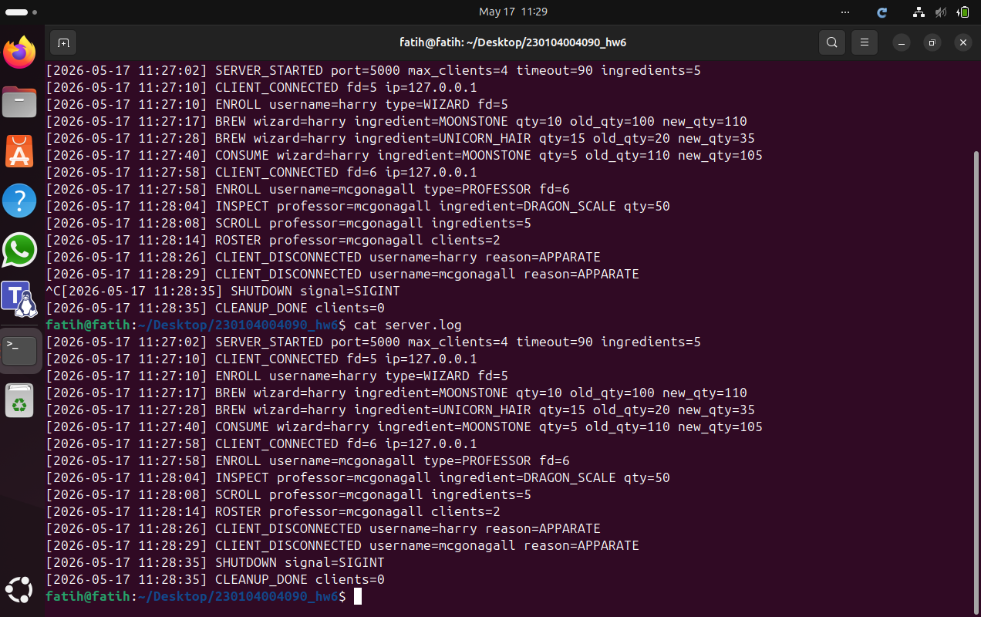

7.3 Scenario 3
Command:
./hogwarts -p 5000 -s ingredients.txt -l server.log -n 3 -t 90
Steps performed: wizard harry, wizard ron, and professor dumbledore connect, filling the server to capacity (n=3). A fourth client (wizard voldemort) and a fifth client (professor snape) are both rejected with ERR HOGWARTS_FULL. harry exits with Ctrl+C, freeing a slot. wizard neville then connects successfully and runs BREW MOONSTONE 5. dumbledore runs ROSTER. ron, dumbledore, and neville exit with Ctrl+C.

Server Terminal
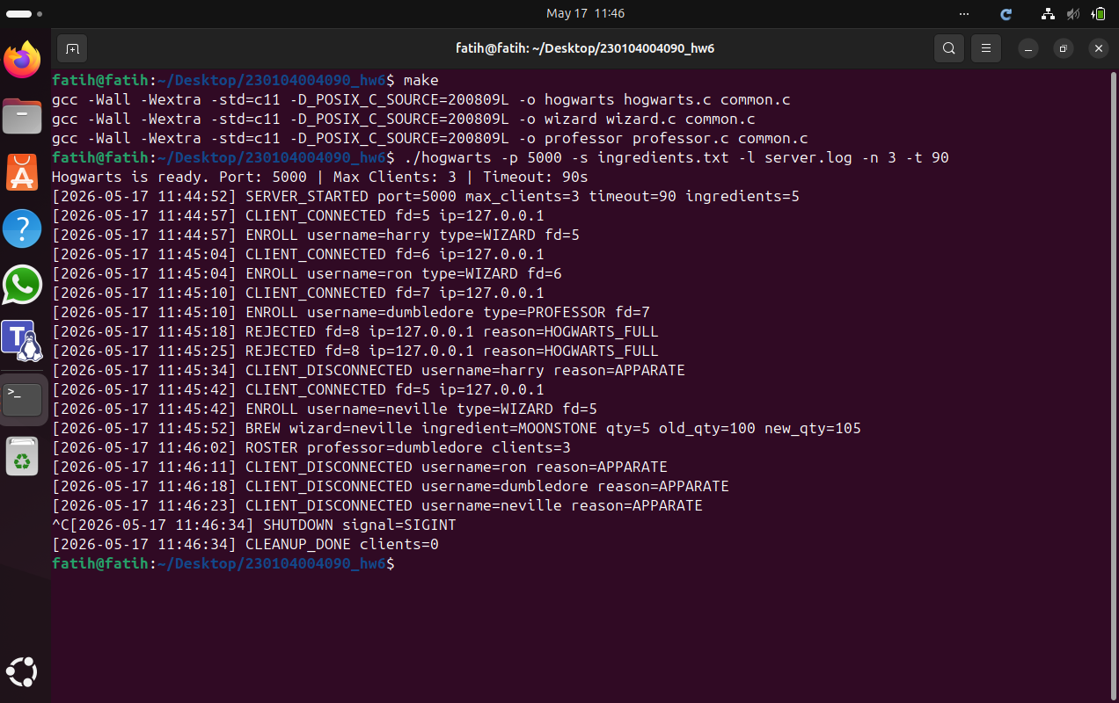

Wizard harry Terminal
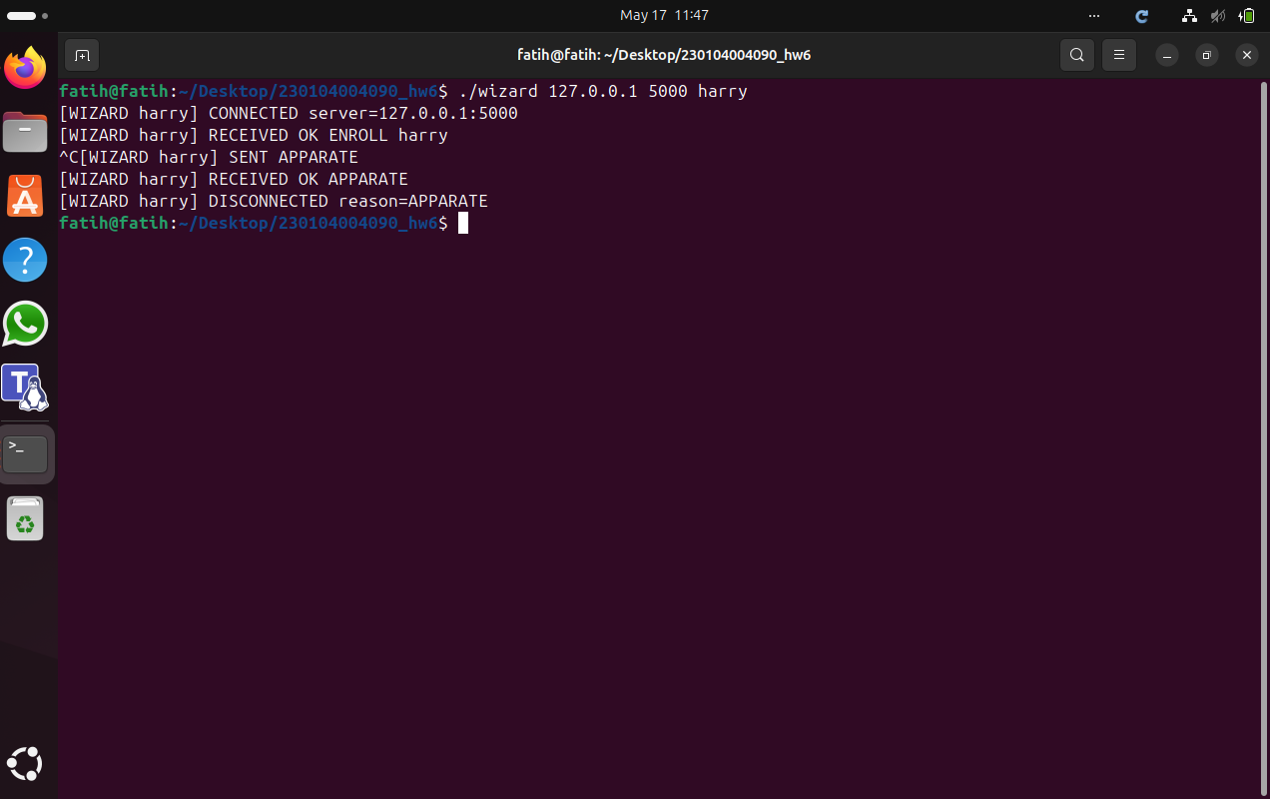

Wizard ron Terminal
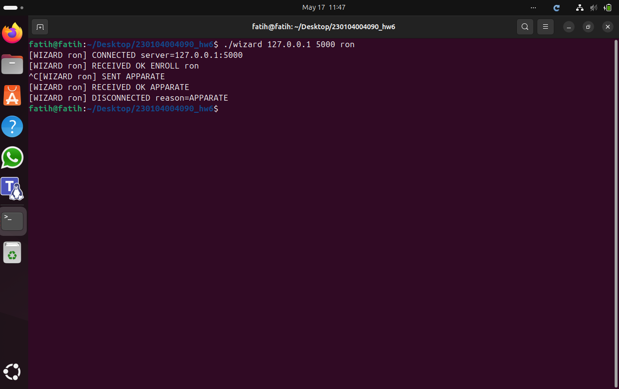

Professor dumbledore Terminal
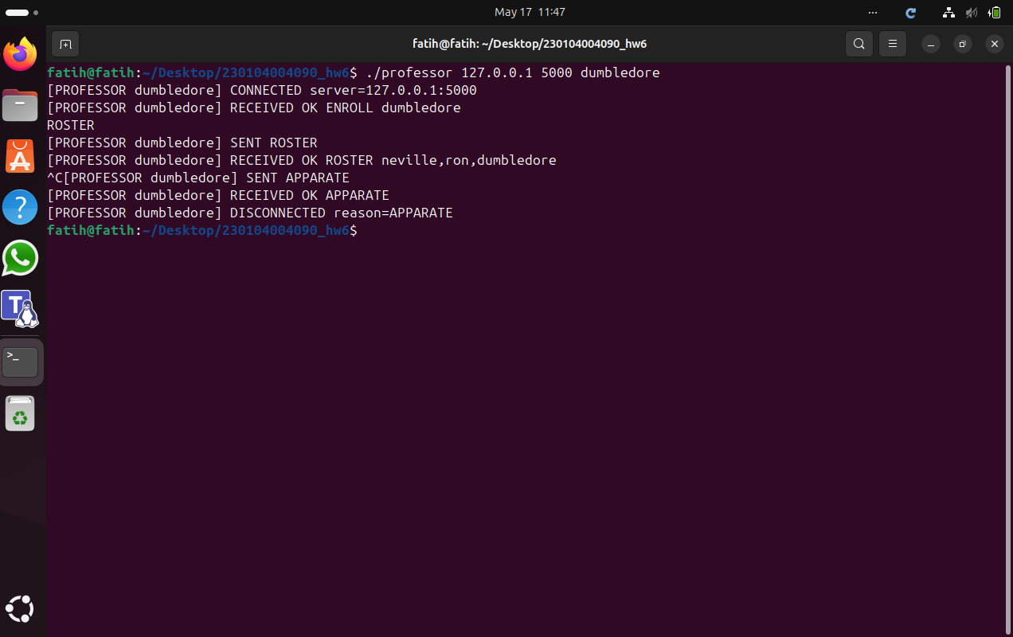

Wizard voldemort Terminal (Rejected)
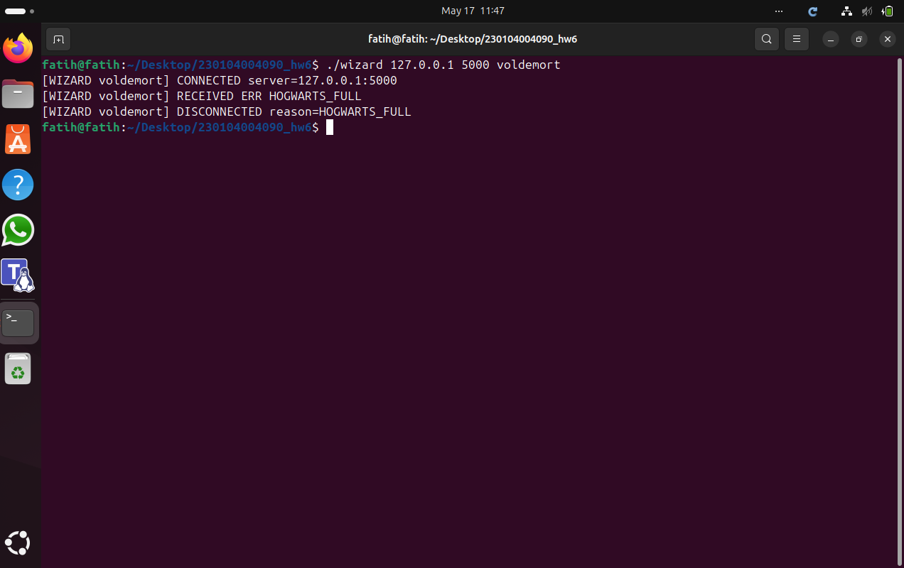

Professor snape Terminal (Rejected)
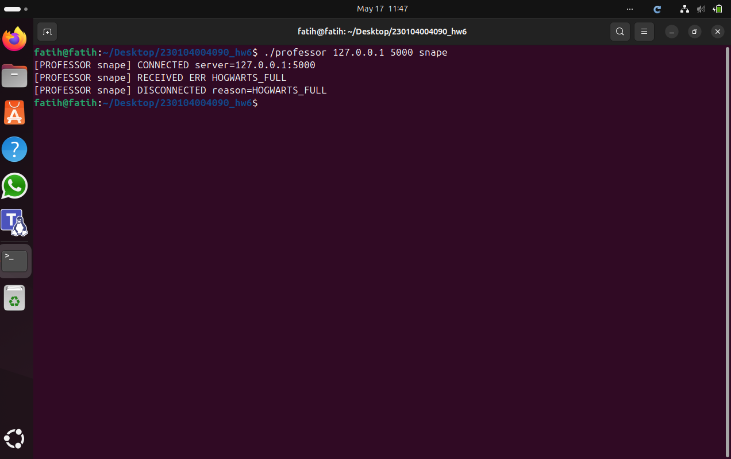

Wizard neville Terminal
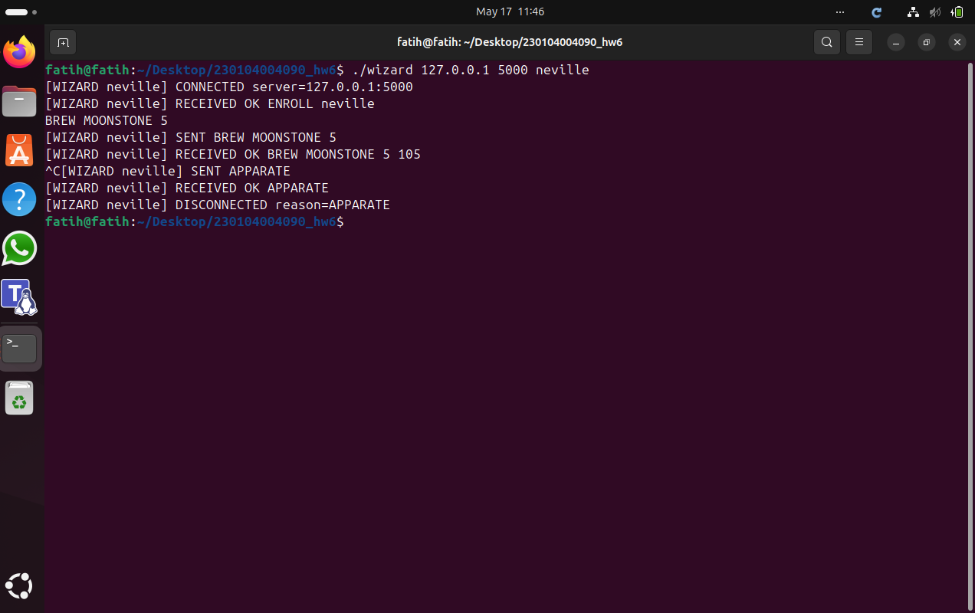

Explanation: The screenshots show that the server rejects new connections with ERR HOGWARTS_FULL once the maximum number of clients is reached, that a slot is recovered when an existing client disconnects, and that a new client (neville) can then connect and operate normally. The ROSTER reply lists exactly the clients that are connected at that moment.
Note: Timeout was set to 90 s (instead of 60 s) only for manual convenience; it does not change the capacity logic shown here.
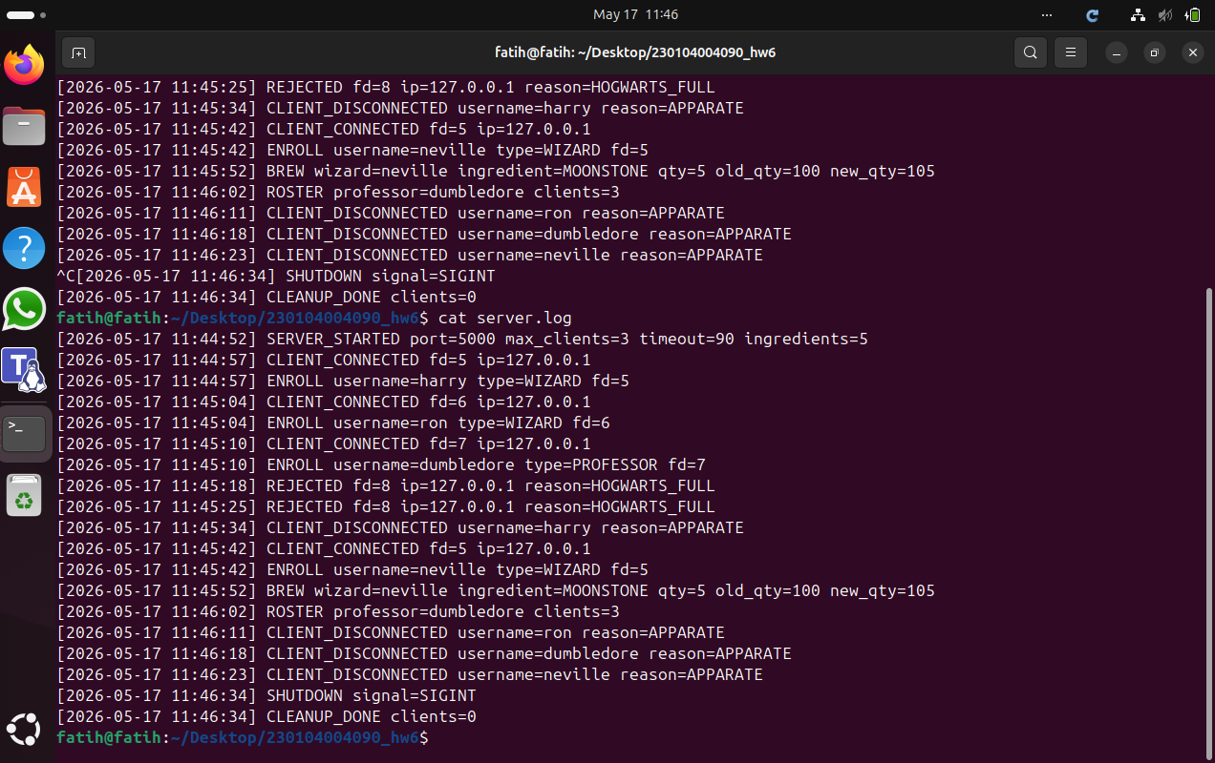

7.4 Scenario 4
Command:
./hogwarts -p 5000 -s ingredients.txt -l server.log -n 6 -t 10
Steps performed: wizard hermione and wizard harry connect. hermione runs BREW MOONSTONE 5, SPELLBOOK, BREW DRAGON_SCALE 2. harry sends no command at all and is automatically disconnected after the 10-second idle timeout. New clients wizard ron, professor dumbledore, and professor mcgonagall then connect and run BREW UNICORN_HAIR 5, SCROLL, and ROSTER respectively. Finally Ctrl+C is sent to the server terminal, ps aux | grep hogwarts is run to show no leftover process, and cat server.log is run.

Server Terminal
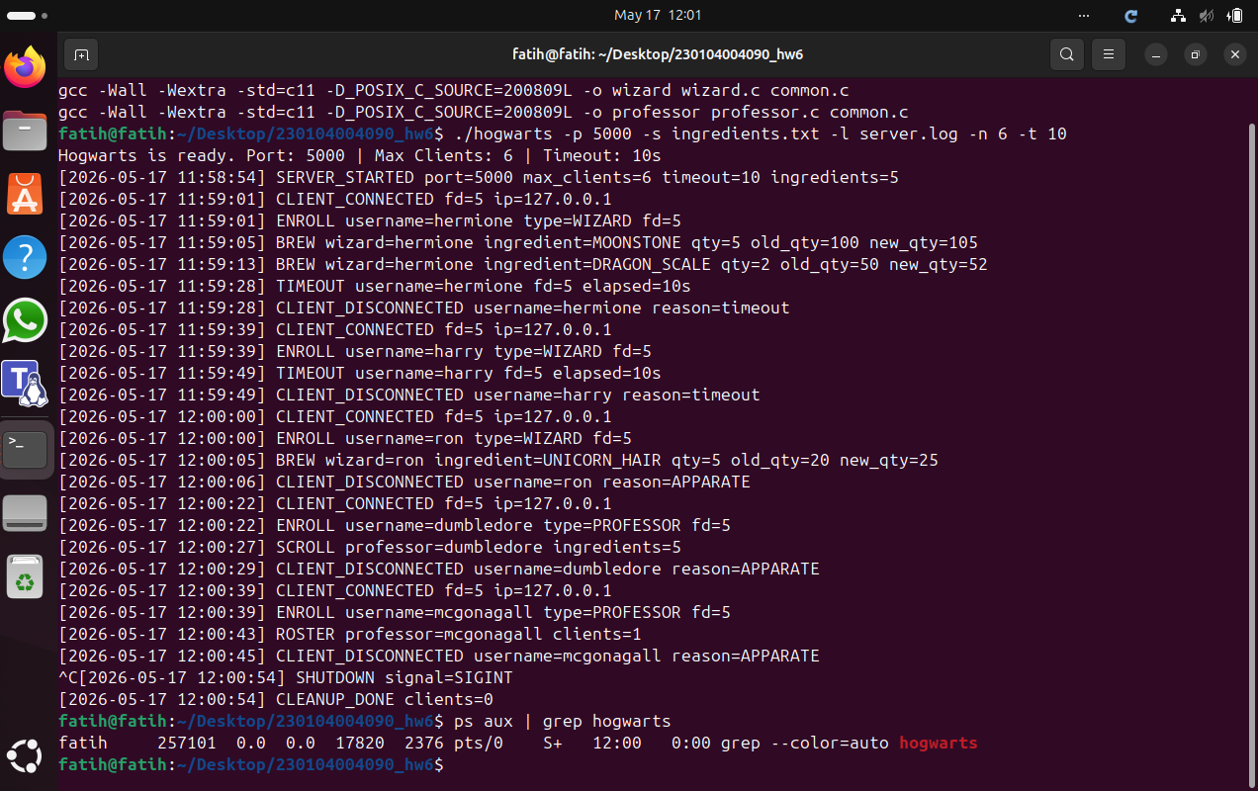

Wizard hermione Terminal
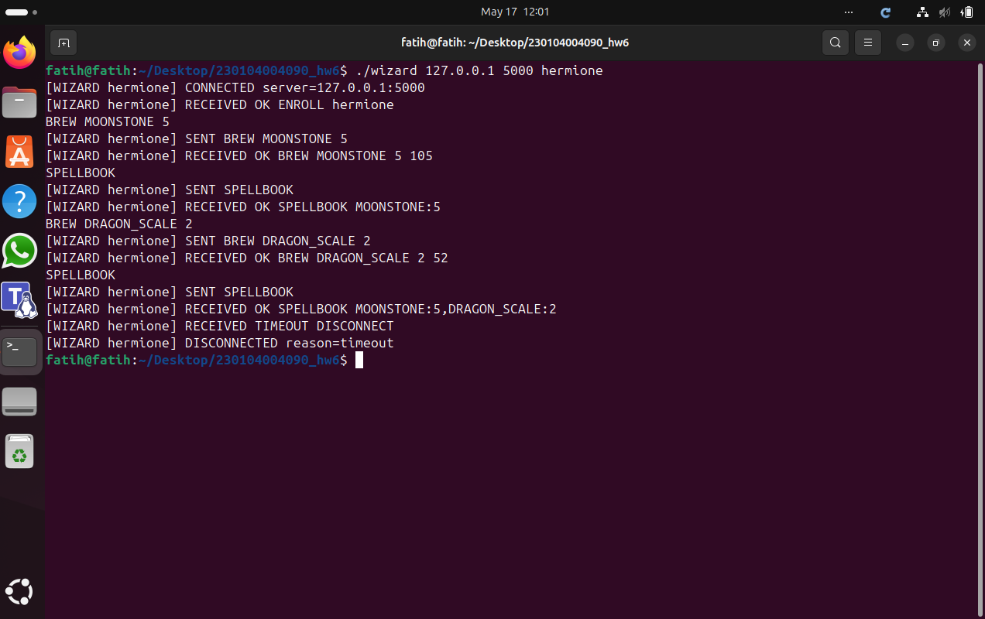

Wizard harry Terminal (Idle Timeout)
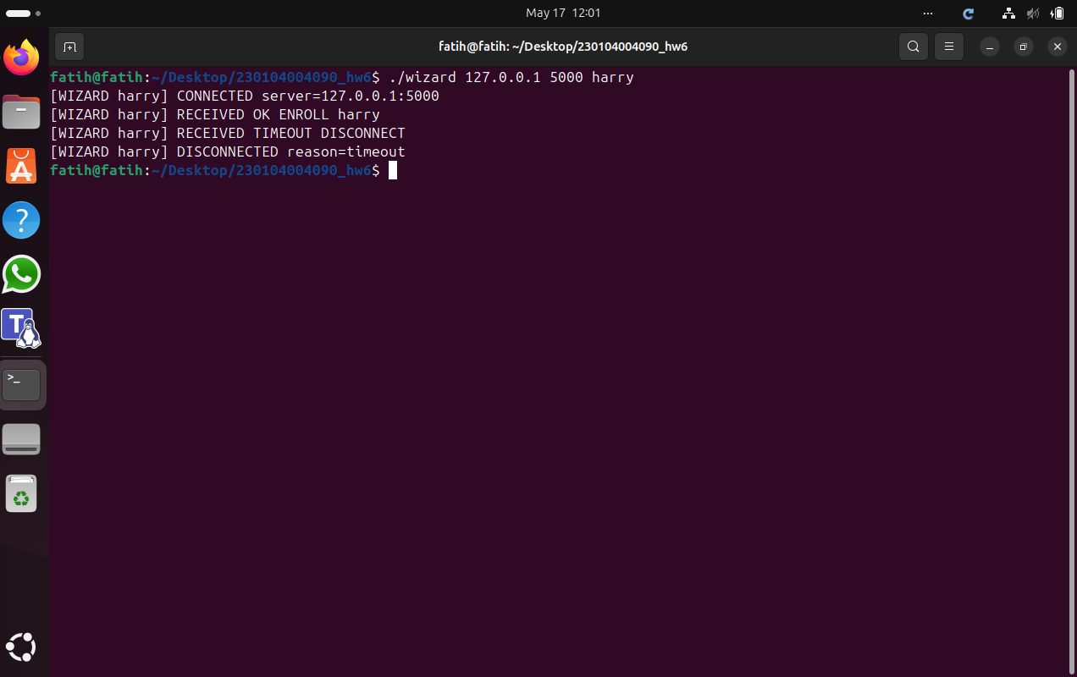

Wizard ron Terminal
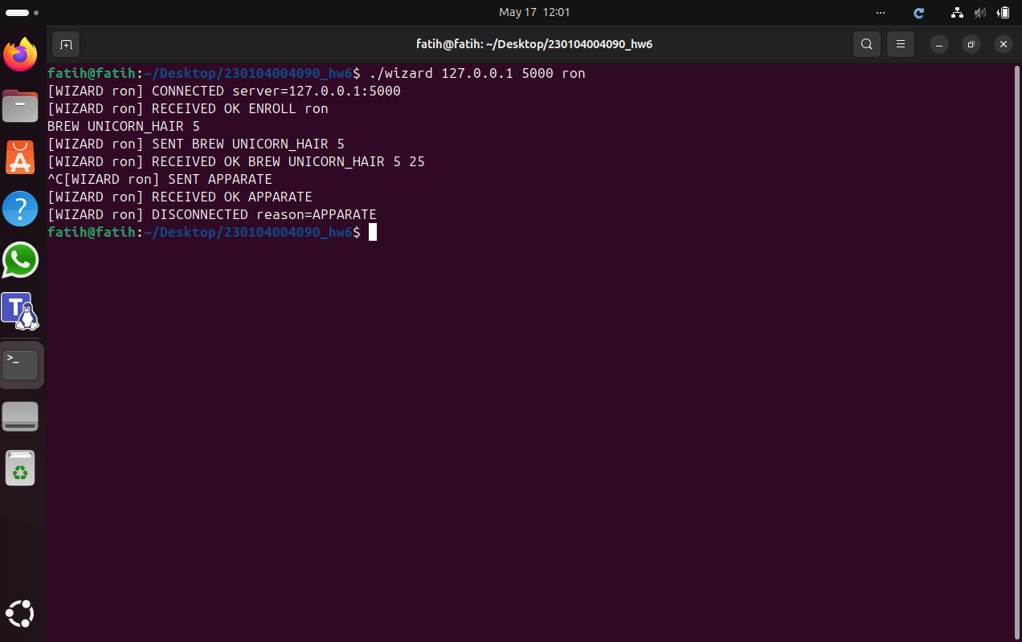

Professor dumbledore Terminal
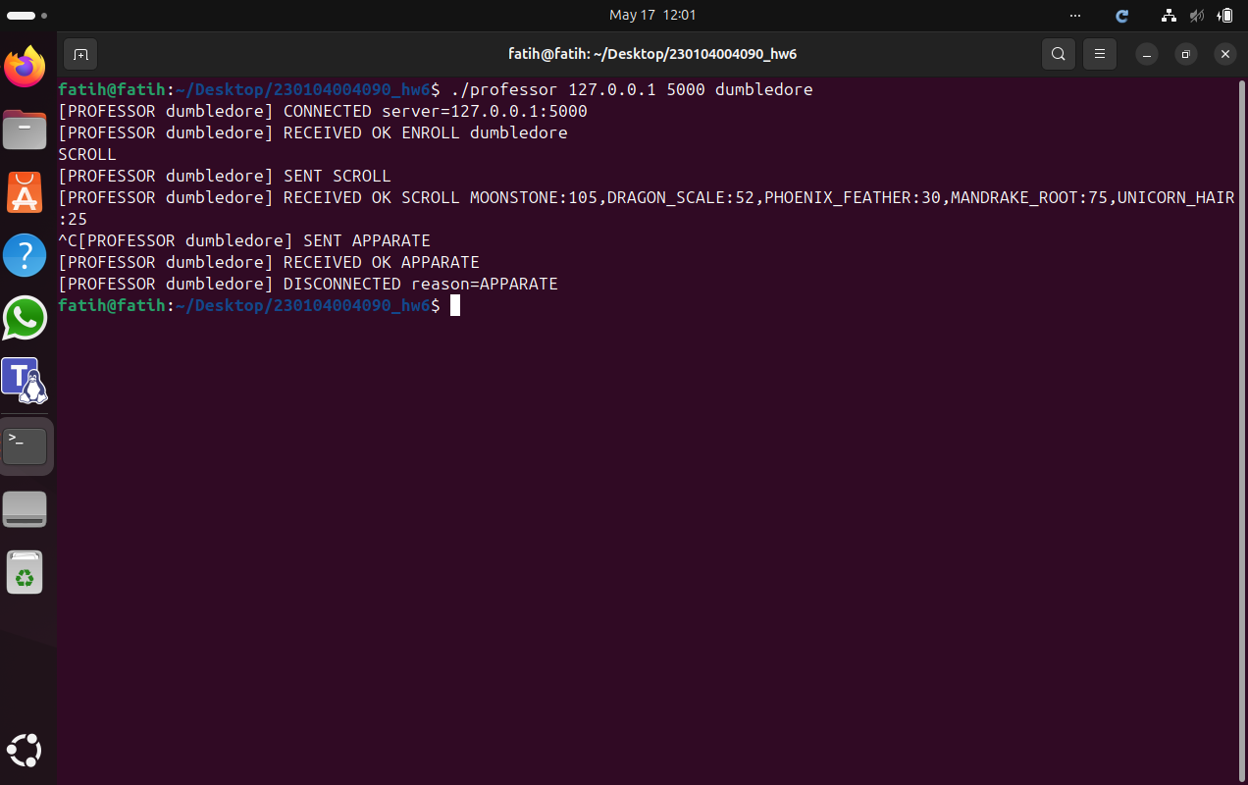

Professor mcgonagall Terminal
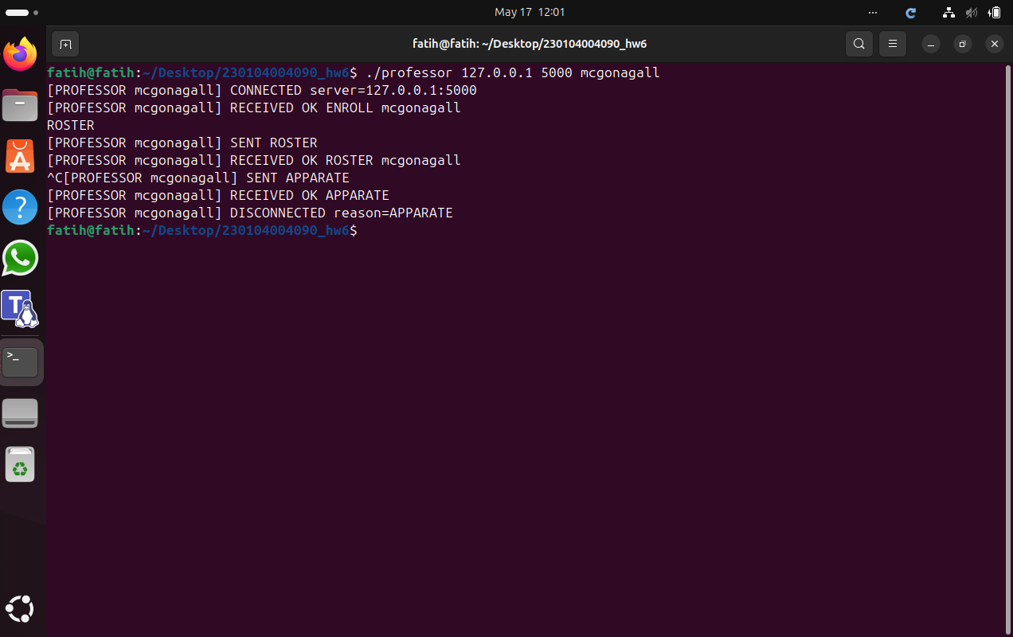
Explanation: The screenshots show that a client which sends no command is automatically disconnected after the configured idle timeout, with the server logging TIMEOUT username=harry fd=N elapsed=10s and CLIENT_DISCONNECTED reason=timeout. The ps aux | grep hogwarts output confirms that no hogwarts process remains after shutdown (only the grep line is shown), proving there are no orphan processes or leaked descriptors. Note: This scenario uses the specified 10 s timeout; the 90 s value in Scenarios 1-3 was only for manual convenience, the mechanism is identical.
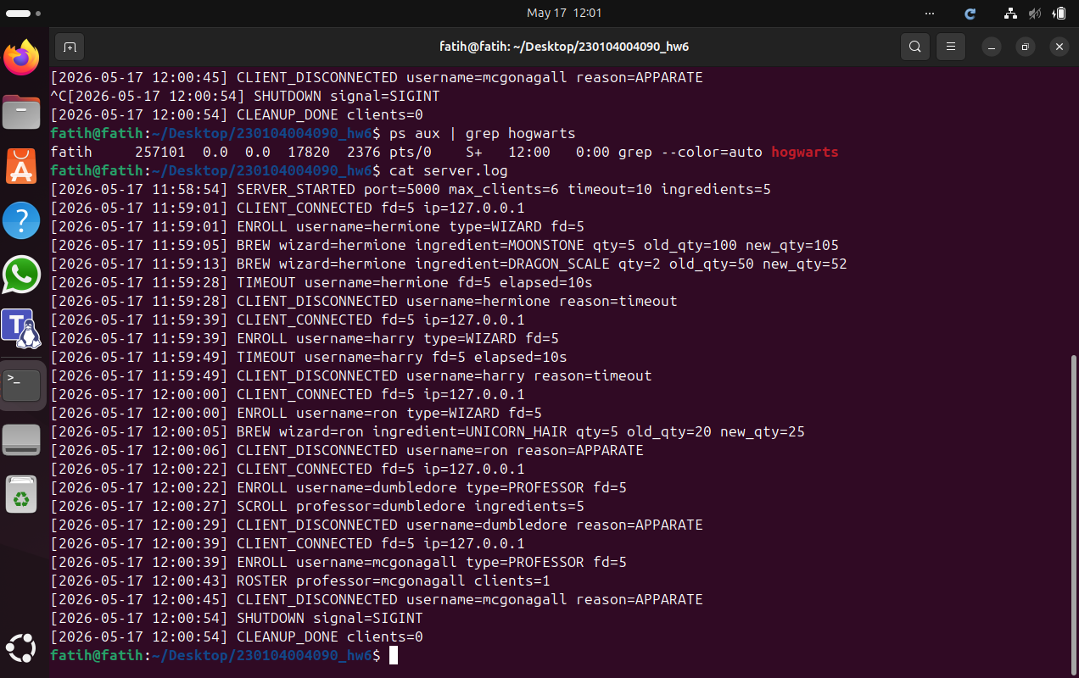

8. Challenges

8.1 Recomputing the select() Timeout Without sleep() or Threads
The first challenge was enforcing the idle timeout while keeping the server single-threaded and free of sleep(). A fixed select() timeout would either disconnect clients too late or wake the loop unnecessarily often. The solution was to compute, before every select() call, the earliest moment at which any connected client could time out, and to pass exactly the remaining time until that moment as the select() timeout. When select() returns (either because data arrived or because the timeout elapsed), the loop re-runs the idle sweep, so clients are disconnected at the right time without busy-waiting and without a separate timer thread.

8.2 Handling Partial TCP Messages and Clean Disconnection
The second challenge was correctly reassembling commands when TCP delivered partial or merged lines, while also freeing all resources on every kind of disconnection (APPARATE, idle timeout, and abrupt hangup). This was solved with a per-client line buffer that accumulates bytes across reads and only processes complete newline-terminated lines, keeping any leftover partial line for the next read. A single disconnect routine is used for all three disconnection cases; it closes the socket, frees the client record, and clears the table slot, which prevents file-descriptor and memory leaks and also makes the freed capacity immediately reusable for new connections.

